**BIG DATA MANAGEMENT**

**ANKUR AGARWAL**

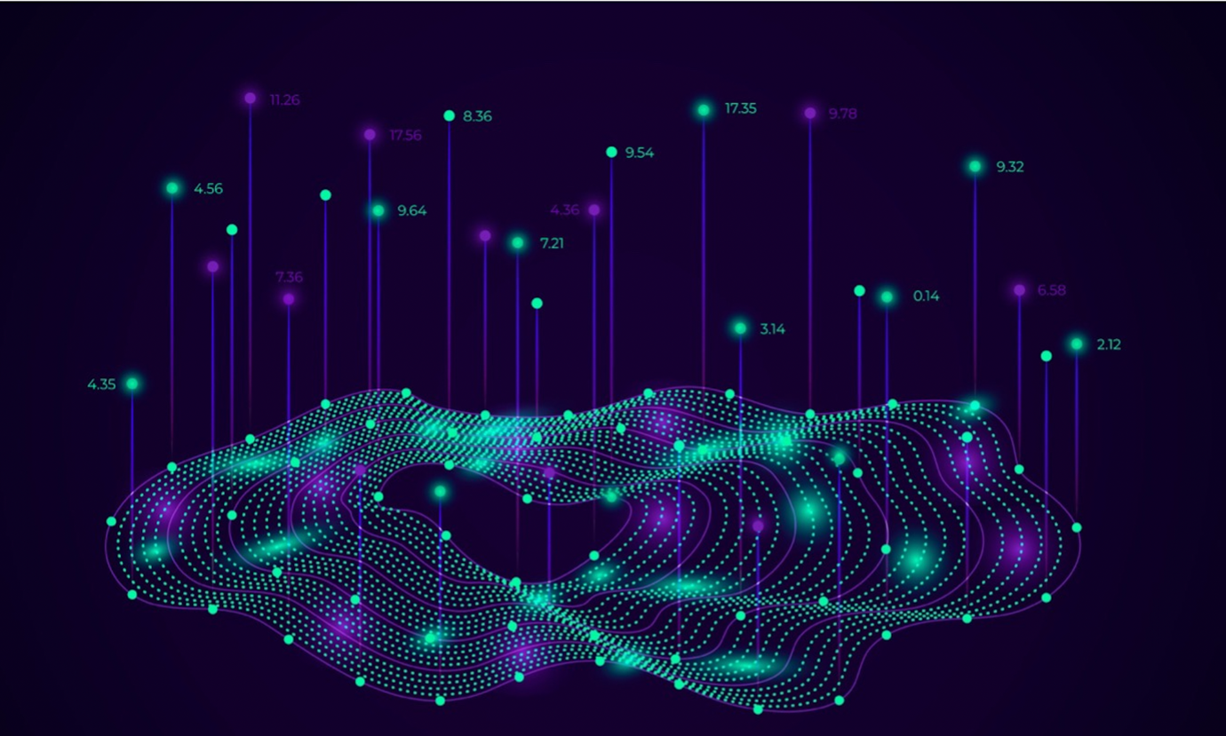

**CONTENTS**

1. **Introduction**
2. **Evolution of Big Data Paradigms**
   1. **Big Data Characteristics** 
      1. **Big Data Volume**
      2. **Big Data Variety**
      3. **Big Data Velocity**
      4. **Big Data Veracity**
      5. **Big Data Value**
      6. **Big Data Variability**
   2. **Processing Paradigms of Big Data**

**1.2.1 Batch Processing**

**1.2.2 Real-Time Processing**

**1.2.3 Hybrid Processing**

1. **Exploratory Data Analysis**
2. **Classification**
3. **Clustering**
4. **Graph Analysis**
5. **Big Data Ethics**
   1. **Recommendations**
6. **Improvement of The Game**
7. **Acknowledgement**
8. **GitHub Link**
9. **References**
10. **Introduction**

Large or complex data sets are known as big data because they are too large or complex for traditional data processing applications.

Multidimensional data offer improved statistical power, but complex data may have a higher false discovery rate. The size of big data often exceeds the ability of traditional software to handle it in a timely and effective manner.

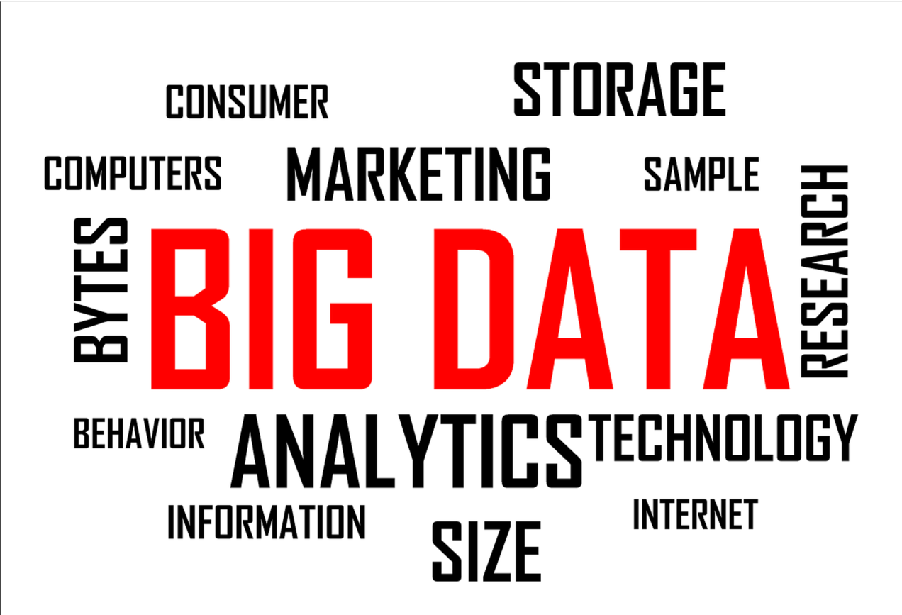

***Figure 1: Figure showing general word cloud for Big Data***

Data sets have grown in size and number rapidly. Data can be collected by many devices, such as mobile devices, wireless sensors, aerial sensors, software logs, cameras, microphones, and radio-frequency identification (RFID) readers. Identifying who should be the owner of big-data initiatives that affect the whole organization is a key issue for large enterprises.

1. **Evaluation of Big Data processing Paradigms**

The term big data describes the enormous amount of structured, semi-structured, and unstructured data. This type of data is too complex for traditional databases to handle. In today's business environment, big data is used for planning, analysis, and product development, as well as customer relationship management.

Business, government, and a multitude of industries and non-profit sectors have generated enormous amounts of data. These data types include textual data (structured, semi-structured, and unstructured), and multimedia files (such as images, videos, and audio) across multiple platforms, such as machine-to-machine communication, social media, sensor networks, and the industrial Internet of Things.

With the massive influx of heterogeneous and complex data being generated every day, anywhere, at any time, on any device, we are living in the age of Big Data. We also call it the Data Deluge.

There are approximately 2.5 quintillion bytes of data created every day by the entire world, with 90% of that data unstructured.

Global data volume is predicted to grow exponentially between 2013 and 2020 from 4.4 zettabytes to 44 zettabytes according to an IDC report. **International Data Corporation** predicted that data would reach 163 zettabytes by 2025.

**2.1 Big Data Characteristics**

**Big data can be described by the following characteristics:**

1. Volume

2. Velocity

3. Variety

4. Veracity

5. Variability

6. Value

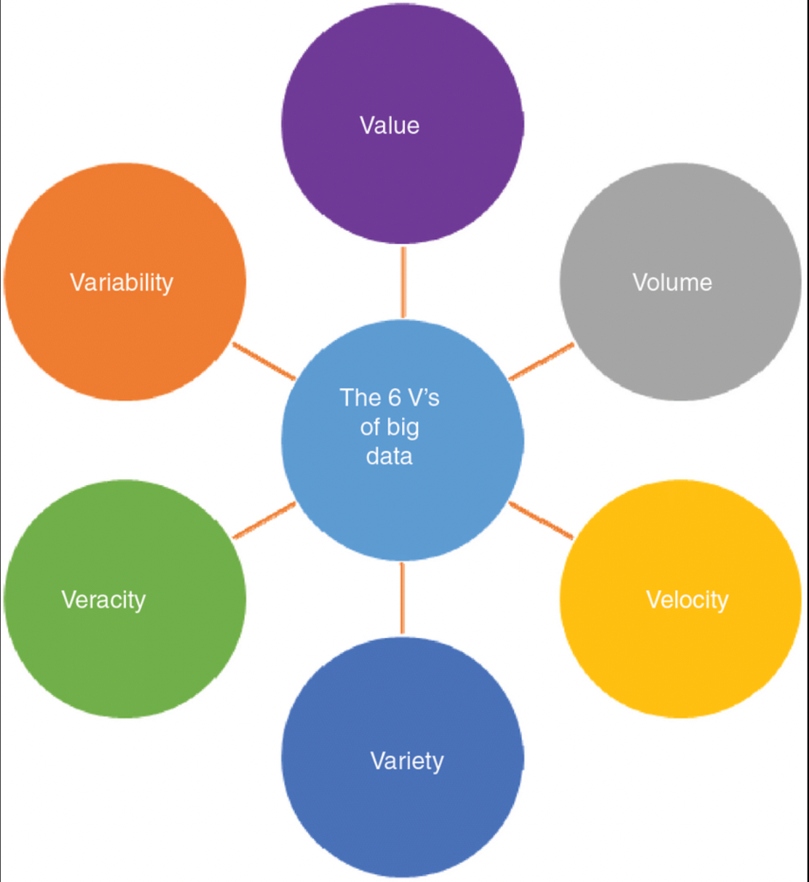

***Figure2: Figure showing 6vs of Big Data***

* + 1. **Big Data Volume**

Data volume is the starting point for big data since it is the size and amount of data collected at the beginning.

Consider downloading all tweets ever written as a dataset. or information related to the 2.3 billion Facebook users, or even, information related to every website on the internet. How can you analyse such a large dataset?

* + 1. **Big Data Velocity**

The velocity of data generation is defined as the rate of data generation. The generation of high-velocity data requires distinct processing techniques. The most popular types of data are structures, texts, tweets, pictures and videos.

* + 1. **Big Data Variety**

Variety refers to the ability to produce structured and unstructured data, which can be generated by humans or machines. Texts, tweets, pictures, and videos are the most common types of data.

* + 1. **Big Data Veracity**

Veracity is an aspect of big data that relates to consistency, accuracy, quality, and trustworthiness. The veracity of data refers to its biases, noise, and anomaly. It may also refer to incomplete data, errors, outliers, or missing values.

* + 1. **Big Data Variability**

Variability refers to the fact that data keeps changing continuously. An important aspect of variability is interpreting the right meaning of raw data.

* + 1. **Big Data Value**

In terms of value, big data refers to the usefulness of the information it gathers.

Without data processing, data isn't worth much by itself - to be valuable, it must be transformed into insights or information.

* 1. **Processing Paradigms of Big Data**

The Big Data concept is based on structured, semi-structured, and unstructured data, which have processing capabilities far beyond what conventional databases can handle. Big Data plays an important role in Big Data processing and analysis in addition to decision making, forecasting, business analysis, product development, customer experience, and loyalty.

Batch processing, real-time processing, and hybrid computation comprise these three categories of processing

* + 1. **Batch Processing**

The process of batch processing occurs when blocks of data are processed that have already been stored over time. An example would be to process all the transactions of a major financial firm in one week. During the course of one day, millions of records are stored as a file or records, etc.

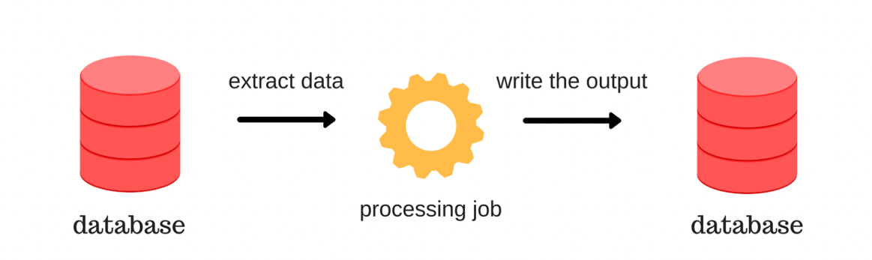

***Figure 3: Figure showing an example of Batch Processing***

* + 1. **Real-time processing**

Real-time processing refers to processing data streams in real-time and creating reports or creating automated responses in real-time (or near-real-time) with minimal latency. Sensor data might, for instance, be used by a real-time traffic monitoring system to detect high traffic volumes. Using these statistics, a map could be dynamically updated to show congestion, or traffic management systems would be automatically initiated.

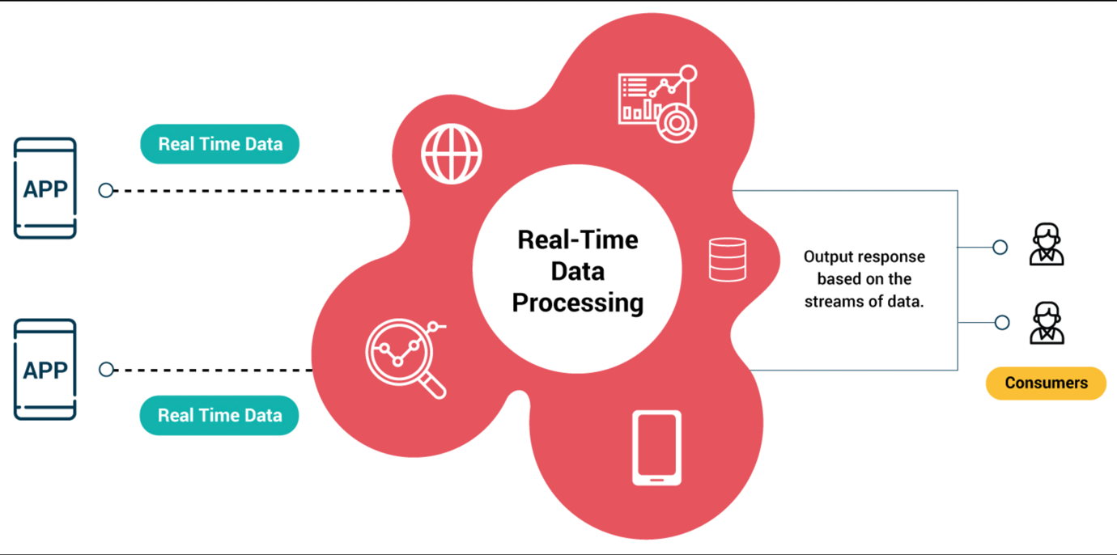

***Figure 4: Figure showing an example of Real-Time Processing***

* + 1. **Hybrid computation**

Hybrid cloud computing is commonly used for big data and analytics applications today. Hybrid clouds comprise on-premises and local cloud resources integrated with public clouds and dedicated clouds for more scalability and computing power for big data and analytics.

1. **Exploratory Data Analysis**

Several factors need to be considered when designing this game's information system.

1. **Rank of Users**

Based on the accuracy and speed of their clicks to completion, users will be ranked individually.

1. **Ranking of teams**

Each team's ranking is publicly available. The maximum number of team members is 30 and the minimum is one.

**3.** **In-Game purchases**

The game offers flamingo-specific binoculars that can be

purchased in-game.

1. **Completion of the game**

A new level is always available in the game, so the challenge never ends.

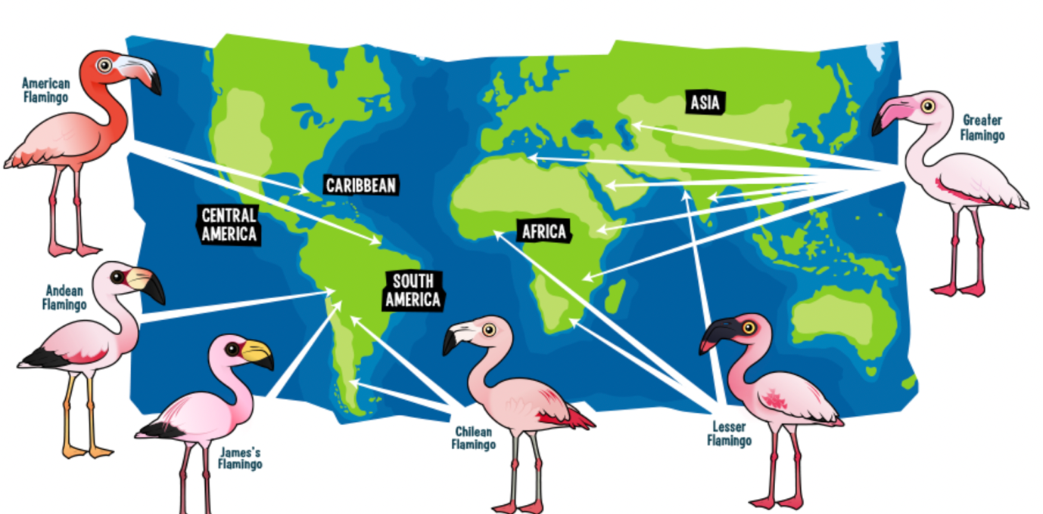

***Figure 5: Figure used to represent cover pic of Game***

**Catch the Pink Flamingo Game Description**

"Catch the Pink Flamingo" is a highly popular mobile game produced by the imaginary company Eglence Inc.

Catch the pink flamingos is an online game where players attempt to capture maximum pink flamingos as possible. During each level, the game will provide real-time prompts to help you move through the maps. The complexity of the maps and mission speed increase as the user advances through the levels.

Pink Flamingos in this multiplayer game are randomly generated on a world map as players reach goals that fluctuate in real-time.

The first thing players (users) do after registering is play Level 1 individually with no teammates. At this point in the game, the player starts building history and getting trained. A player is only allowed to be assigned to one team. It's easy to learn how to play the game on Level 1. Once the user finishes Level 1, the user is given the option of joining a team or forming one of their own. The user will then continue as a team player throughout the rest of the program. The team can be as small as one person.

The game automatically creates a new map each time it begins a new level, adding more cells to the previous map. Additionally, missions become more complicated as the game progresses. Missions also change more often as levels rise.

Players communicate via chat boards assigned to each team as well as social media, such as Twitter.

**Data Set Overview**

In the following table, we provide a brief description of each of the files that are available for analysis

|  |  |  |
| --- | --- | --- |
| **File Name** | **Description** | **Fields** |
| **ad-clicks.csv** | **Database of clicks on ads** | **timestamp, txId, userSessionId, userId, adId, adCategory** |
| **buy-clicks.csv** | **Database of purchases.** | **timestamp, txId, userSessionId, team, userId, buyId, price** |
| **game-clicks.csv** | **A record of each click a user performed during the game.** | **timestamp, clickId, userId, userSessionId, isHit, teamId, teamLevel** |
| **level-events.csv** | **A record of each level event for a team. Level events are recorded when a team ends or begins a new level** | **timestamp, eventId, teamId, teamLevel, eventType** |
| **team-asssignments.csv** | **A record of each time a user joins a team.** | **timestamp, team, userId, assignmentId** |
| **team.csv** | **A record of each team in the game.** | **teamId, name, teamCreationTime, teamEndTime, strength, currentLevel** |
| **user-session.csv** | **A record of each session a user plays.**  **When a team levels up, each current user session ends and a new session begins with the new level.** | **timestamp, userSessionId, userId, teamId, assignmentId, sessionType, teamLevel, platformType** |
| **Database of the game users** | **Database of the game users** | **timestamp, userId, nick, twitter, dob, country** |
| **combined-data.csv** | **buy-clicks.csv game-clicks.csv user-session.csv,** | **userId, userSessionId, teamLevel, platformType, count_gameclicks, count_hits, count_buyId, avg_price** |

***Table 1: Table showing details of CSV files***

**Exploratory Data Analysis Details**

This project includes nine files that contain information on in-app purchases, ad clicks, and gameplay details and four files that contain chat data.

Analyses were conducted using Spark, Python, KNIME, and Neo4j for this project.

After exploring the data, we will move on to preparing it for classification analysis, cluster analysis, and graph analysis.

**By looking at the Bar Plot,** we can see that different categories of ads are shown to different types of users, and this data was extracted from ad-clikcs.csv.

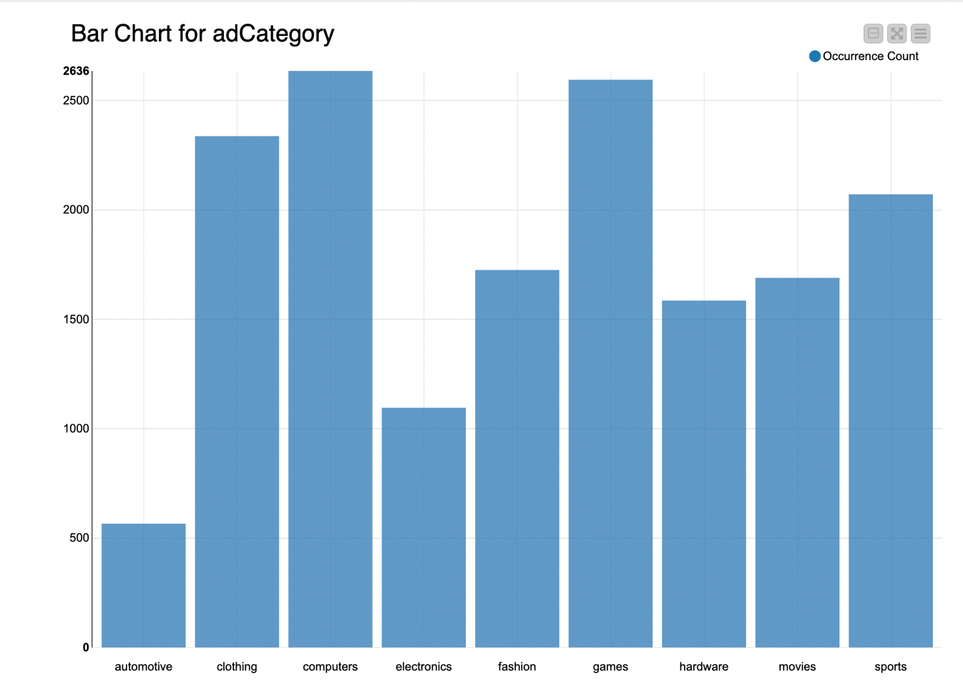

***Figure 6: Figure showing different ad category and their count***

In the plot above, we can see that there was a high number of clicks associated with computers. That sounds like an effective advertisement people who play games are interested in good quality hardware configurations and they are always on the lookout for gaming computers and laptops. People are least interested in automobile ads.

Extrapolating information from the buy-clicks CSV file about the price, we can find that the total price for In-app purchases is 21,407, and only six unique items are available in-app.

|  |  |
| --- | --- |
| **Total App Purchases** | **Total Unique Items to Buy** |
| **21407** | **6** |

Below is a lollipop graph that **shows the spending by different teams during the game**. There is no doubt that team no 28 made the least purchases and team no 27 made the most purchases

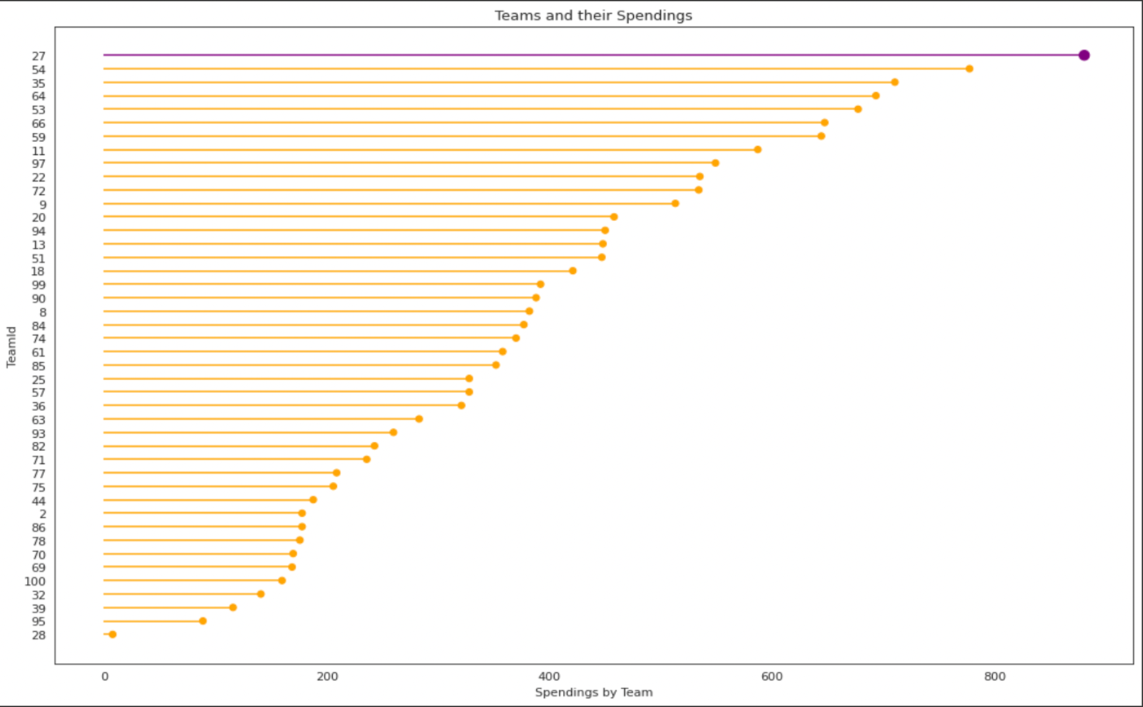

***Figure 7: Figure showing teams and their spending***

As they buy goods, members of team no 27 can be viewed as potential customers. There is a higher likelihood of them buying new products if ads are shown to these people of high-quality items

**Correlation matrix**

Analysing data using a correlation matrix is very helpful. It is a method of summarizing data to understand relationships between different variables and take appropriate action Correlation matrix was made from combined-data.csv

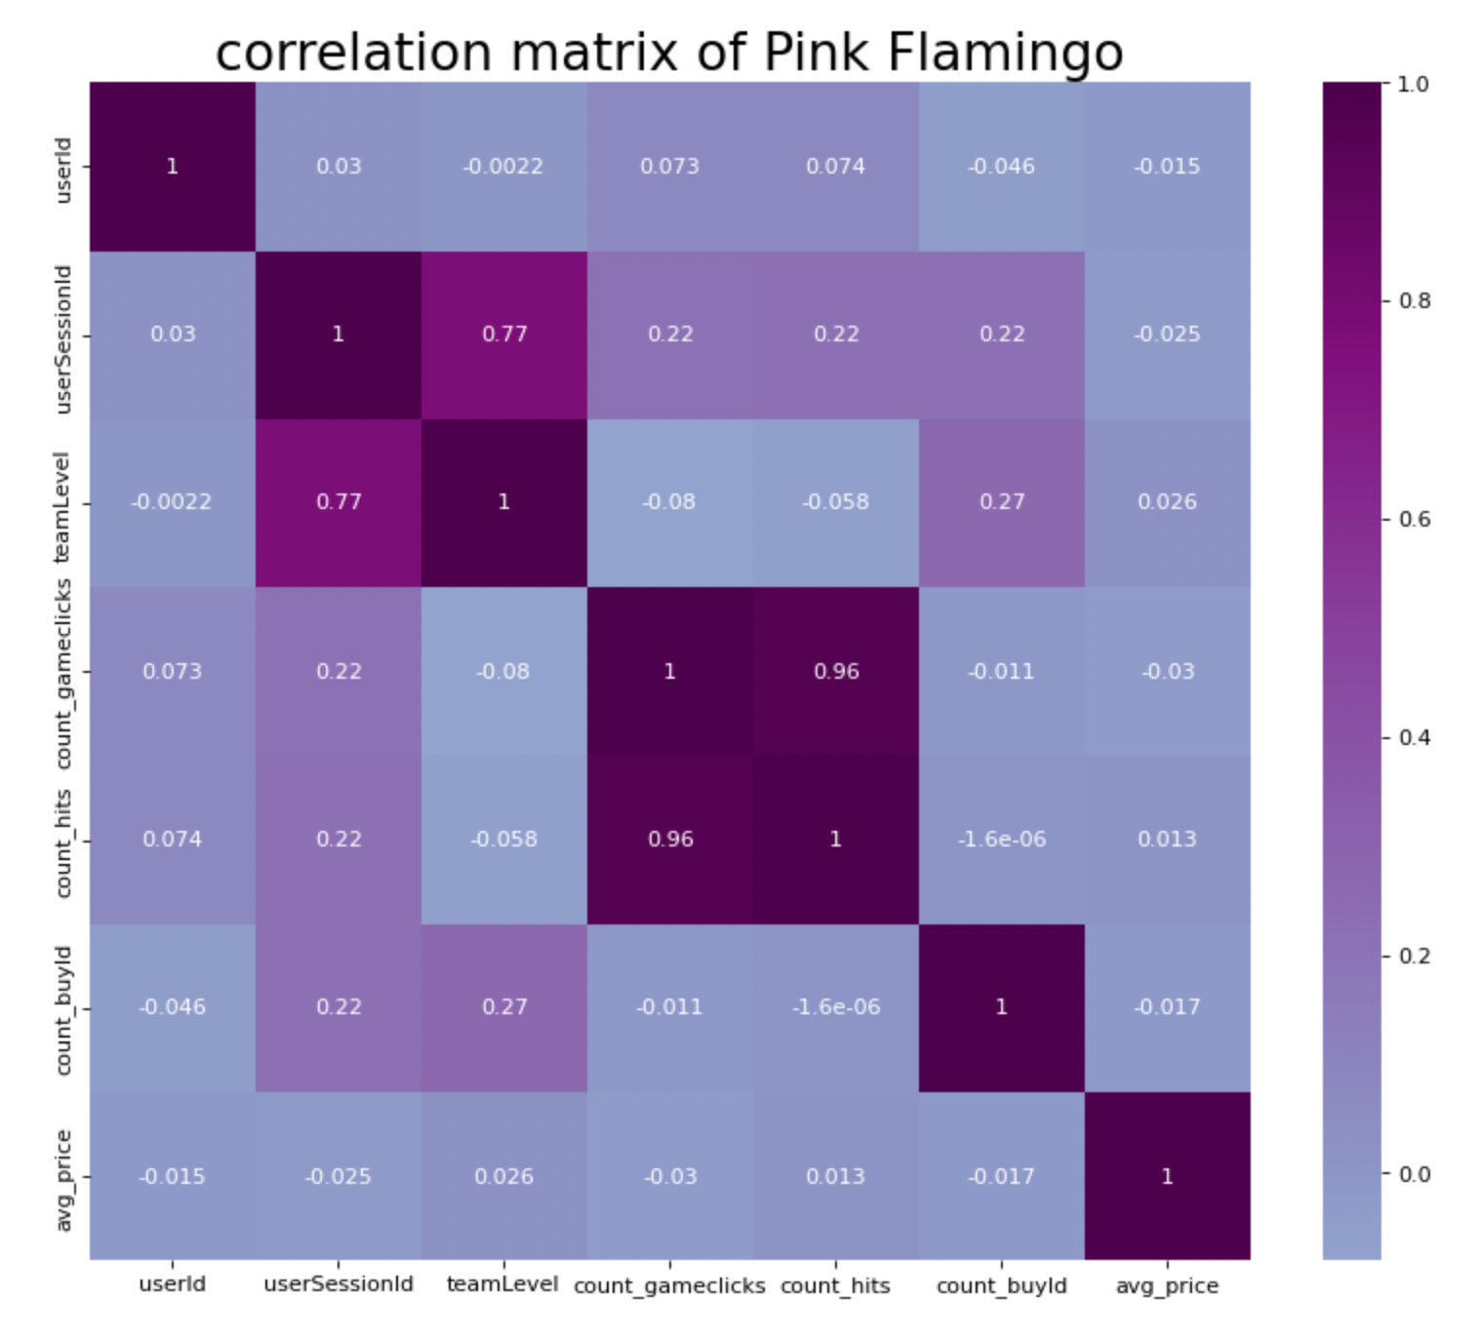

***Figure 8: Correlation matrix***

Since all variables in the table are perfectly correlated, the correlation coefficients along the diagonal are all equal to 1.

We can see a high correlation coefficient between count_gameclicks and count_hits.

**Analysing Players' age group count and players' Date of Birth**

Generally, people don't play games that they find too challenging. Developers need to take this into account when making a game. Different genders and age groups have clearly different abilities when it comes to playing video games. Our analysis predicts what age group is most likely to play games. It's clear that people from ages 30 to 39 enjoy playing games the most.

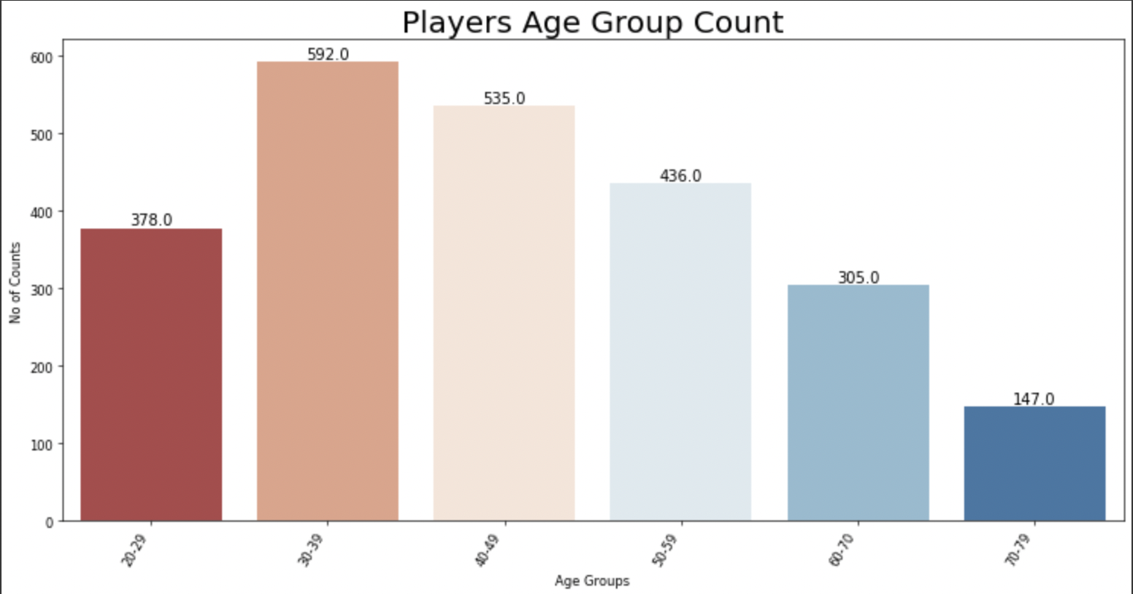

***Figure 9: Figure showing Age Group and no of counts using buy_clicks.csv***

By analyzing the date of birth we can show people more ads on their birthday week and offer some discounts on their birthdays. Many people take advantage of birthday discounts.



**Analysing High Spending Continents**

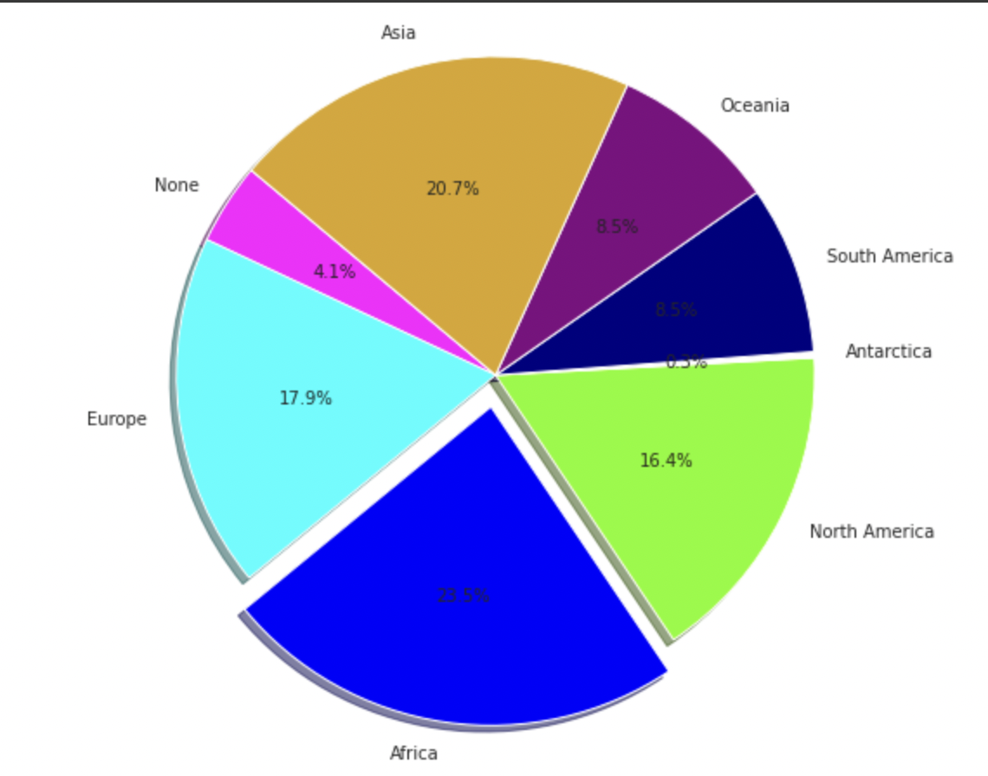

***Figure 10: Figure showing percentage of spending per continent***

The Gaming Market is expected to reach USD 339.95 billion by 2027, up from USD 198.40 billion in 2021.

Analyzing which countries are famous for the game and which countries are playing it is important. Analyzing spending habits across various continents can be beneficial for marketing. To attract more players, it is important to understand the target countries. Additionally, ads can be tailored accordingly by knowing the country and continents where users are located. Consider the example of the preferences and needs of an Asian customer versus those of a customer living in Antarctica. This means that ads must be tailored accordingly. According to our dataset, Africa is the continent with the highest spending.

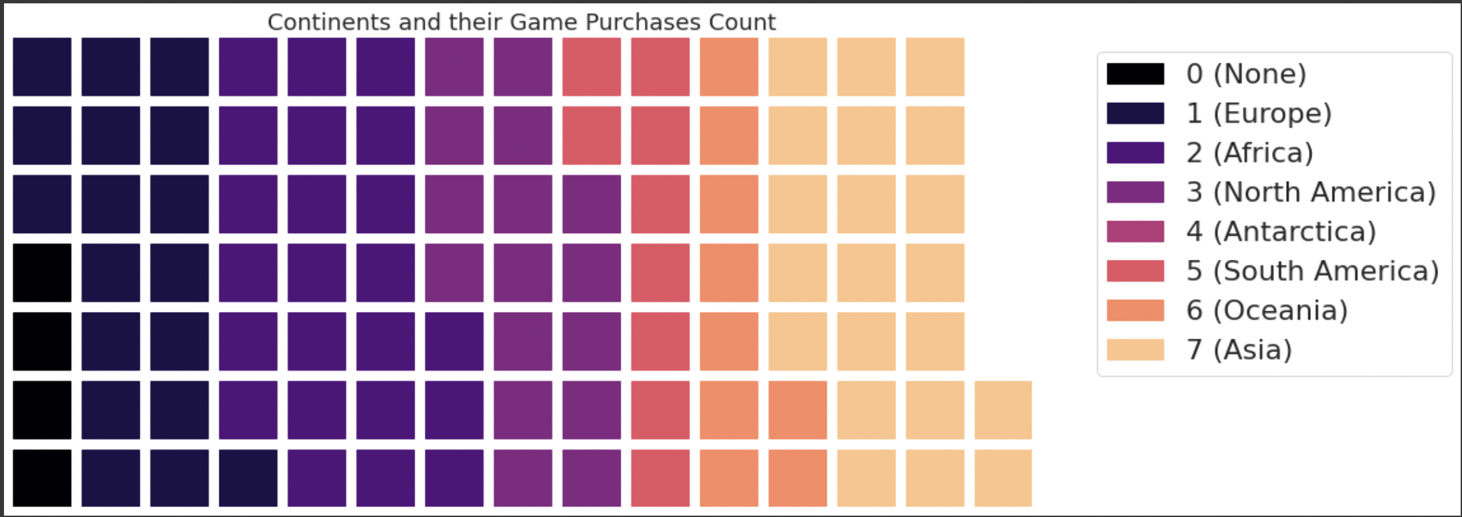

***Figure 11: Figure showing waffle Chart for Continents and their game purchase.***

**Gaming device used for playing**

User-session.csv is the file used to analyse devices.

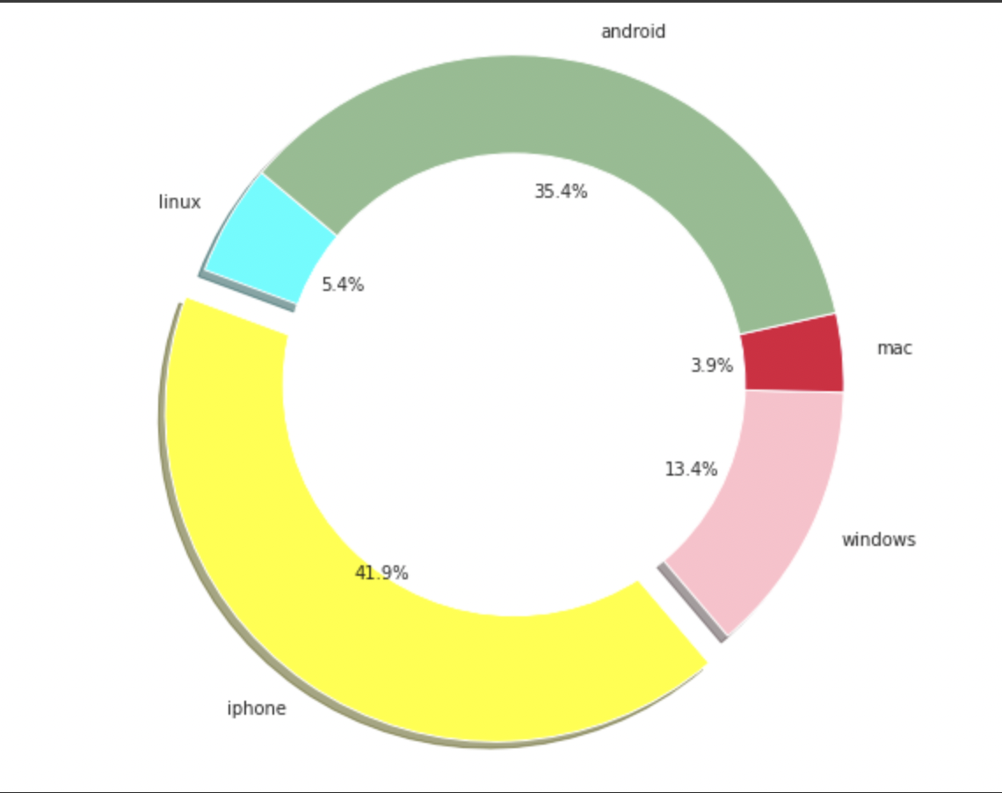 ***Figure 12: Pie chart showing devices percentage used in playing***

As we can see, most players use iPhones to play Catch the Pink Flamingo. Playing games on a variety of devices can have a significant impact on how well players perform. In addition to device targeting, we can choose which ads are shown on which devices.

Depending on the type of device used, we may even be able to extract more information in future.

A game's success can be measured by how many active users it has per month. Since last month, how many new users have you received? Are your users spending much time in your game, too?

The greater the number of players in your application, the better your chances of getting them to upgrade to a paid account and start spending money on your application or recommending it to others.

1. **Classification Analysis**

Eglence, Inc. generates more revenue from purchases of expensive items than from purchases of inexpensive items. In order to market such products to these users, it is necessary to identify users who are more likely to purchase expensive items.

**MoneySpender** and **CheapStake** are referred to users buying expensive items and Inexpensive items, respectively.

Inexpensive items cost $5.00 or less, while big-ticket items cost $5.00 or more.

KNIME’s decision-tree tool was used to fit prediction trees to identify which users were CheapStakes and which ones were MoneySpenders based on the attributes of each user. The combined-data.csv file is used for the analysis.

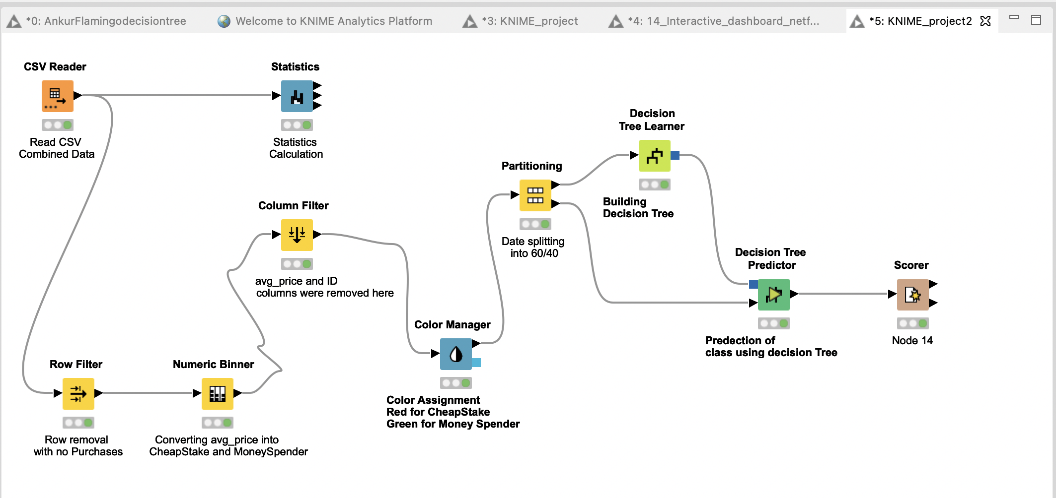

***Figure13: Figure showing workflow used in KNIME***

|  |  |
| --- | --- |
| **Node Name** | **Purpose to Use** |
| **CSV Reader** | **Read CSV Files** |
| **Statistics** | **This node calculates statistical moments such as minimum, maximum, mean, standard deviation** |
| **Row Filter** | **The node allows for row filtering according to certain criteria** |
| **Numeric Binner** | **An attribute was created that allows an analysis of players based on categorization into two categories** |
| **Column Filter** | **By using this node, input columns can be filtered while the remaining columns are sent to the output table.** |
| **Color Manager** | **Colors can be assigned for either nominal (possible values have to be available) or numeric columns** |
| **Partitioning** | **Input data are divided into two partitions, i.e., train data and test data.** |
| **Decision Tree Learner** | **In main memory, this node generates a classification decision tree** |
| **Decision Tree Predictor** | **The node predicts the class value for a new pattern based on an existing decision tree.** |
| **Scorer** | **Used for confusion Matrix and Accuracy Statistics** |

A test dataset was then applied to the trained model. In order to build the model, a categorical attribute has to be created since the objective is to determine whether the player belongs to the MoneySpender or CheapStake categories.

A train dataset and a test dataset were created. A decision tree model was created based on the train dataset

As seen below avg_price was converted into two categories CheapStake and MoneySpender.

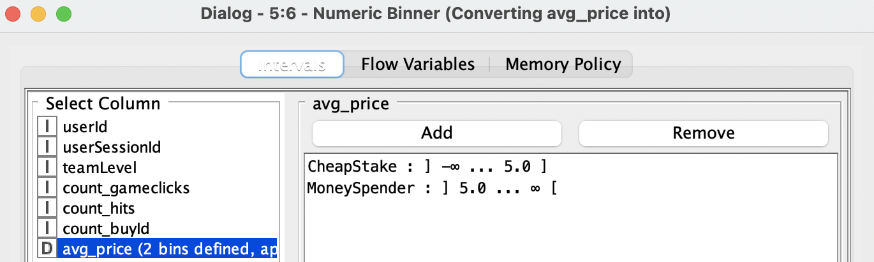

***Figure 14: Coversion of Avg price into CheapStake and MoneySpender***

The decision tree in KNIME was fitted to determine which players are MoneySpenders and CheapStakes based on their known attributes. Following is a screenshot of the resulting decision tree:

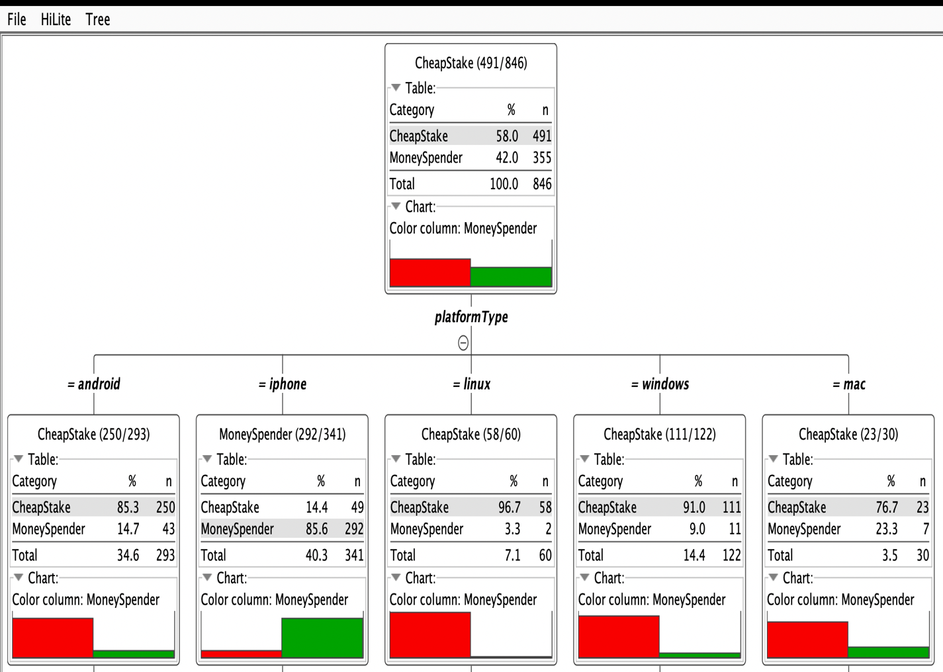

***Figure 15: Figure showing Decision Tree***

The majority of MoneySpenders are contributed by iPhone users. Users who use other platforms are mostly CheapStake.

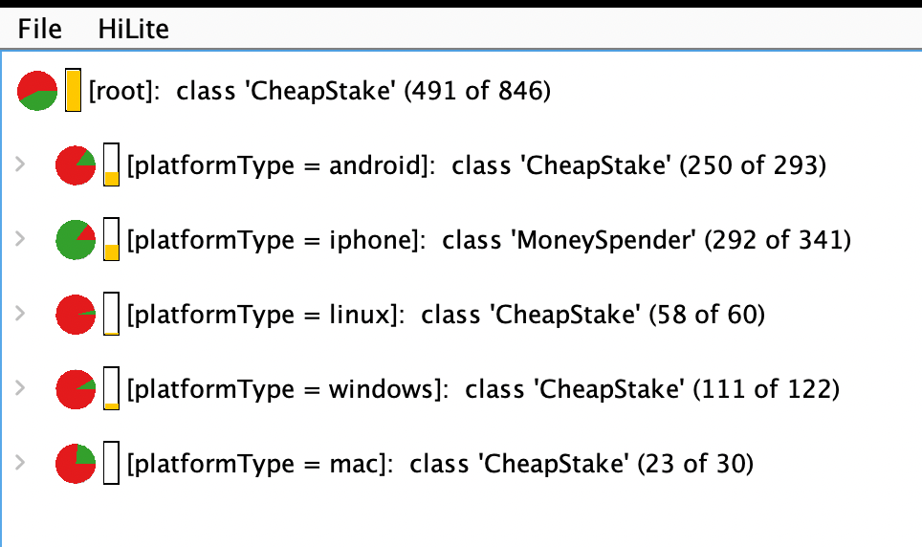***Figure16: Figure showing device users and the ratio of Cheapskate and Money Spender***

The model has correctly classified 279 CheapStake and 158 High Rollers, with an accuracy of 77.34 %.

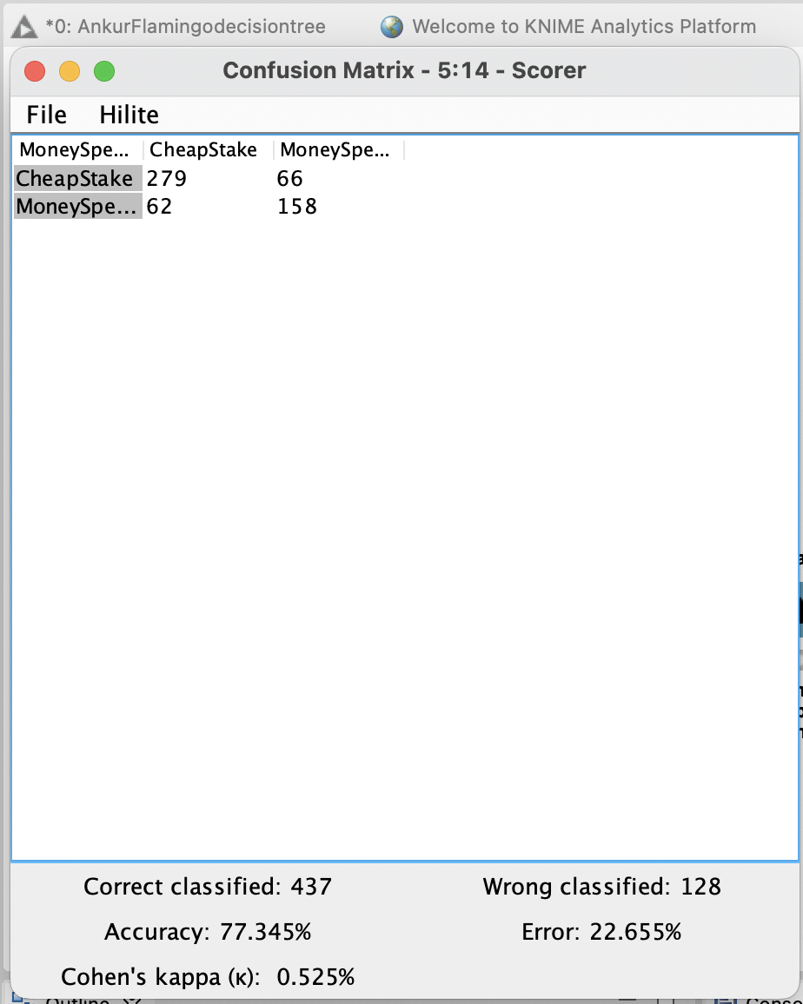

***Figure 17: Figure Confusion Matrix using KNIME***

**2. Clustering**

Clustering is the process of dividing data points or populations into similar groups, such that data points within similar groups are similar in nature. Clustering is a method of unsupervised machine learning. By clustering data points into similar groups, clustering can improve the accuracy of supervised learning algorithms. Buy-clicks.csv and teams.csv were used for the scatterplot considering the parameters price and strength.

It is possible to increase revenue and profitability by implementing different strategies for targeting marketing and charging different fees for hosting in-app purchase items.

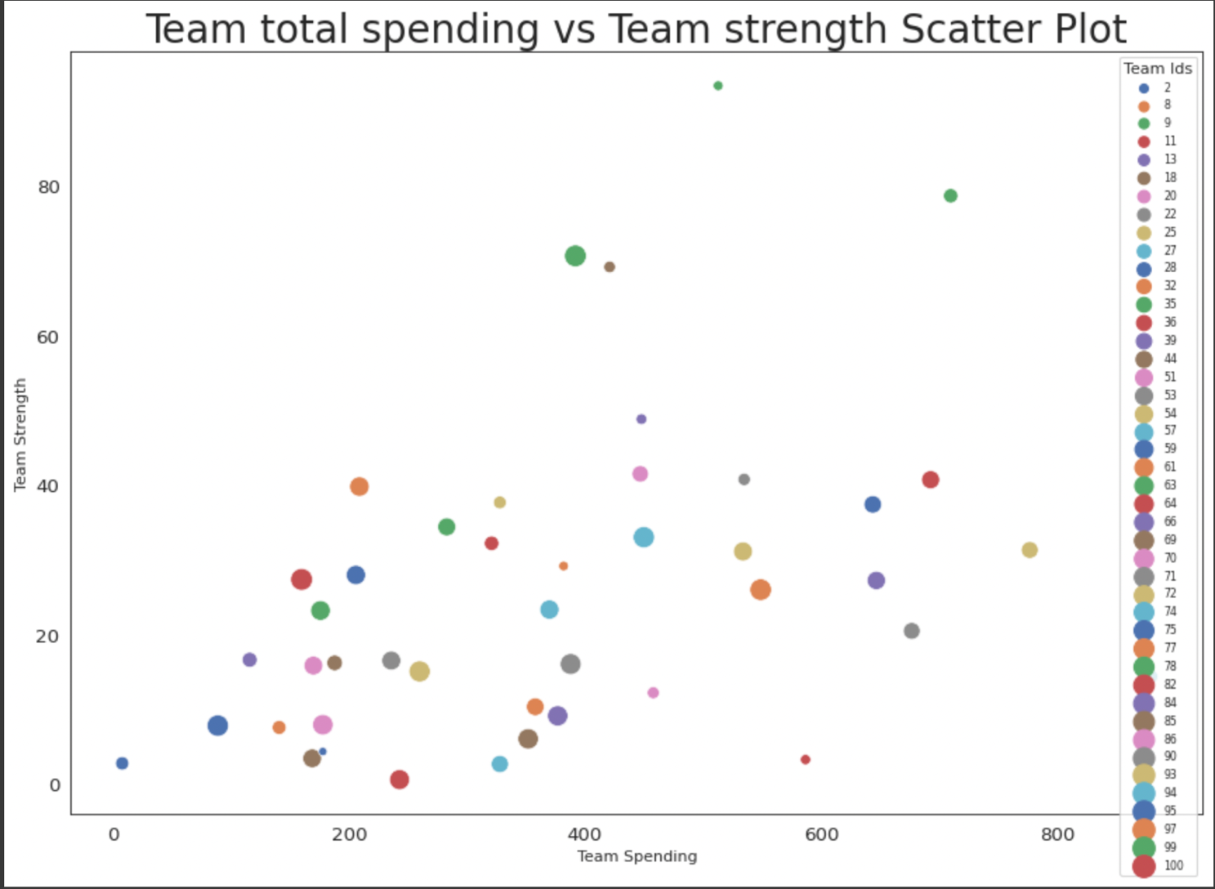

***Figure 18: Figure showing scatterplot***

Clustering was performed on combined-data.csv using the method of K-Means Clustering.

Unsupervised learning is carried out by k-means clustering, which is used when the data is not labelled (e.g., there are no categories or groups). In this algorithm, the variable K represents how many groups are present in the data.

In k-means clustering, the elbow method is used to determine the optimal number of clusters.

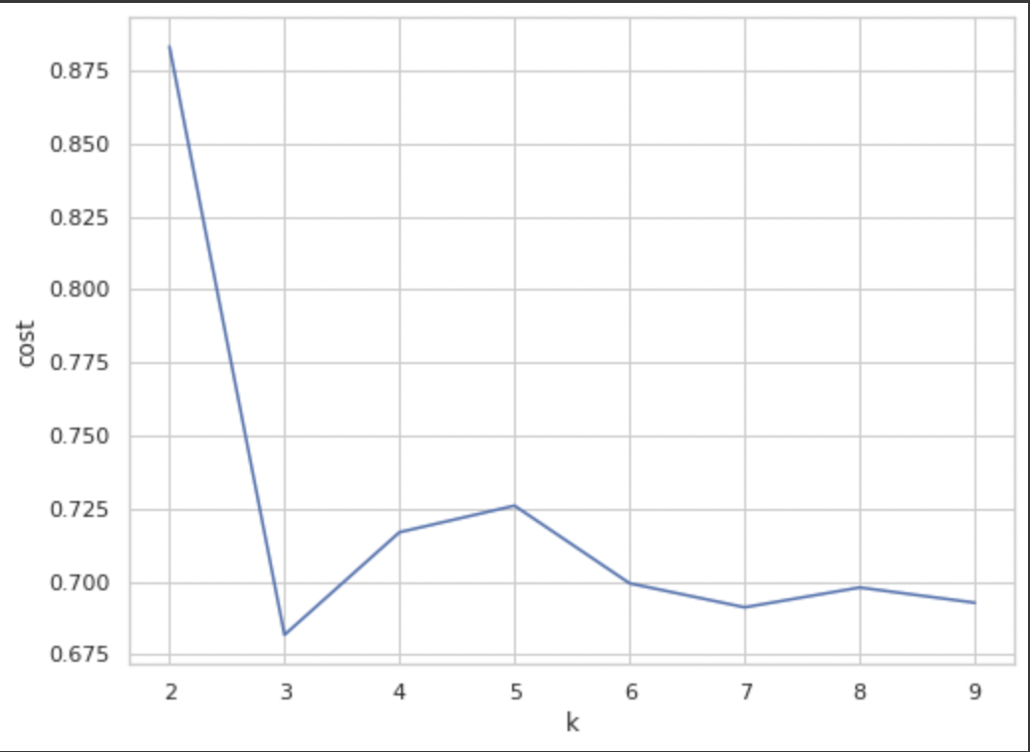

***Figure 19: Figure showing K Means Clustering making Elbow at 3***

We must select a value of k at the elbow in order to determine the optimal number of clusters.  As a result, we conclude that the ideal number of data clusters for the given data is three.

Based on 3 user attributes: Total Price, Total Hit Counts, and Team Level, we performed cluster analysis in Spark to identify 3 distinct groups of users. This led to the following cluster centres:

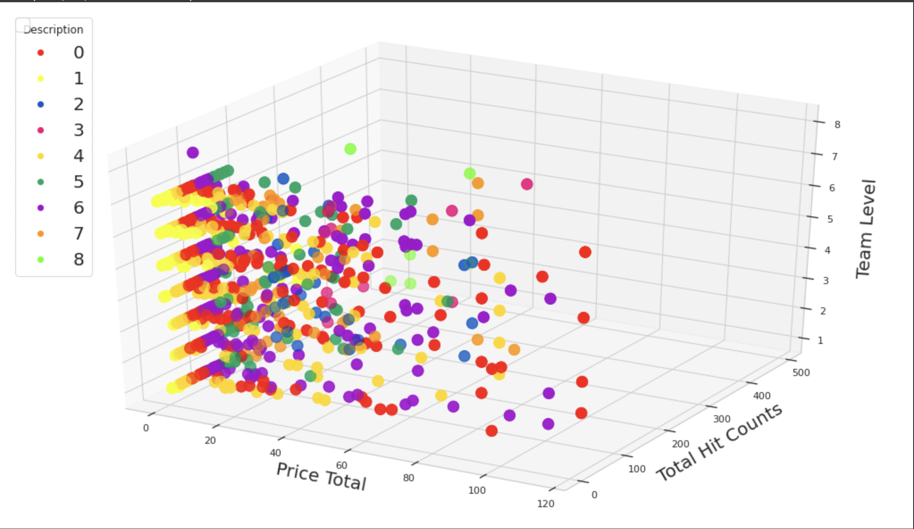

***Figure 20: 3D plot for Price Total , Total Hit Counts and Team Level***

**2. Graph Analysis**

The CSV files with the header provided in them are loaded using the raw file link from Github. After that, we use the merge clause, so that any previously created nodes are used. else create new ones. Thus, there are no duplicate nodes in the database. In this case, the id is converted to an integer with the toInteger function since the data is in string format. We then create a relationship between the nodes using the variables assigned to them. We converted the epochMillis-format date into a DateTime stamp using the DateTime function. The time function was applied to the DateTime stamp because only time was necessary. In the end, we display the nodes for the graph created from the query.

**The following table outlines the six CSV files used to construct the chat graph database.**

|  |  |  |
| --- | --- | --- |
| **File** | **Description** | **Example** |
| chat_leave_team_chat.csv | When a user leaves a team, a new record is going to be added to this file.  Creates an edge labeled “Leaves” from User to TeamChatSession. | Userid: the current user's ID  teamchat_session_id: a uniqueID for the chat session  Timestamp: time of the operation |
| chat_join_team_chat | When a user joins a team, a new record is going to be added to this file.  Creates an edge labeled “Joins” from User to TeamChatSession. | user_id, Userid: the current user's ID  teamchat_session_id : a uniqueID for the chat session  Timestamp: time of the operation |
| chat_mention_team_chat | When a user gets a mention, a new record is going to be added to this file.  Creates an edge labeled “mentions” between the ‘user’ node and ‘chattext’ node | chat_item  Timestamp: time of the operation  Userid: the current user's ID |
| chat_respond_team_chat | When a player with chatid2 responds to a post by another player with chatid2, a new line is added in this file | chatid1: unique id for a chat , chatid2: unique id for a chat, timestamp: time of the chat |

***Table 2: Table showing details of Chat CSV Files***

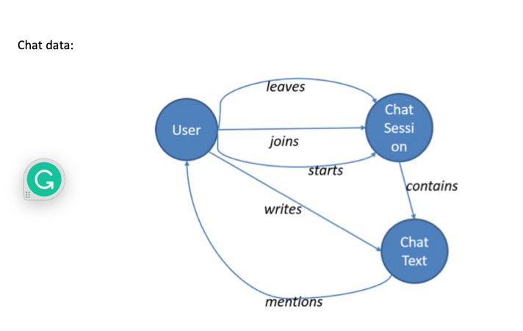

***Figure 21: Figure showing chat data relations***

In the figure below, you can see the graphical representation of the **chat_leave_team_chat** dataset. It represents the users leaving chat session. For example, 1196 user joins and leave chat multiple times.

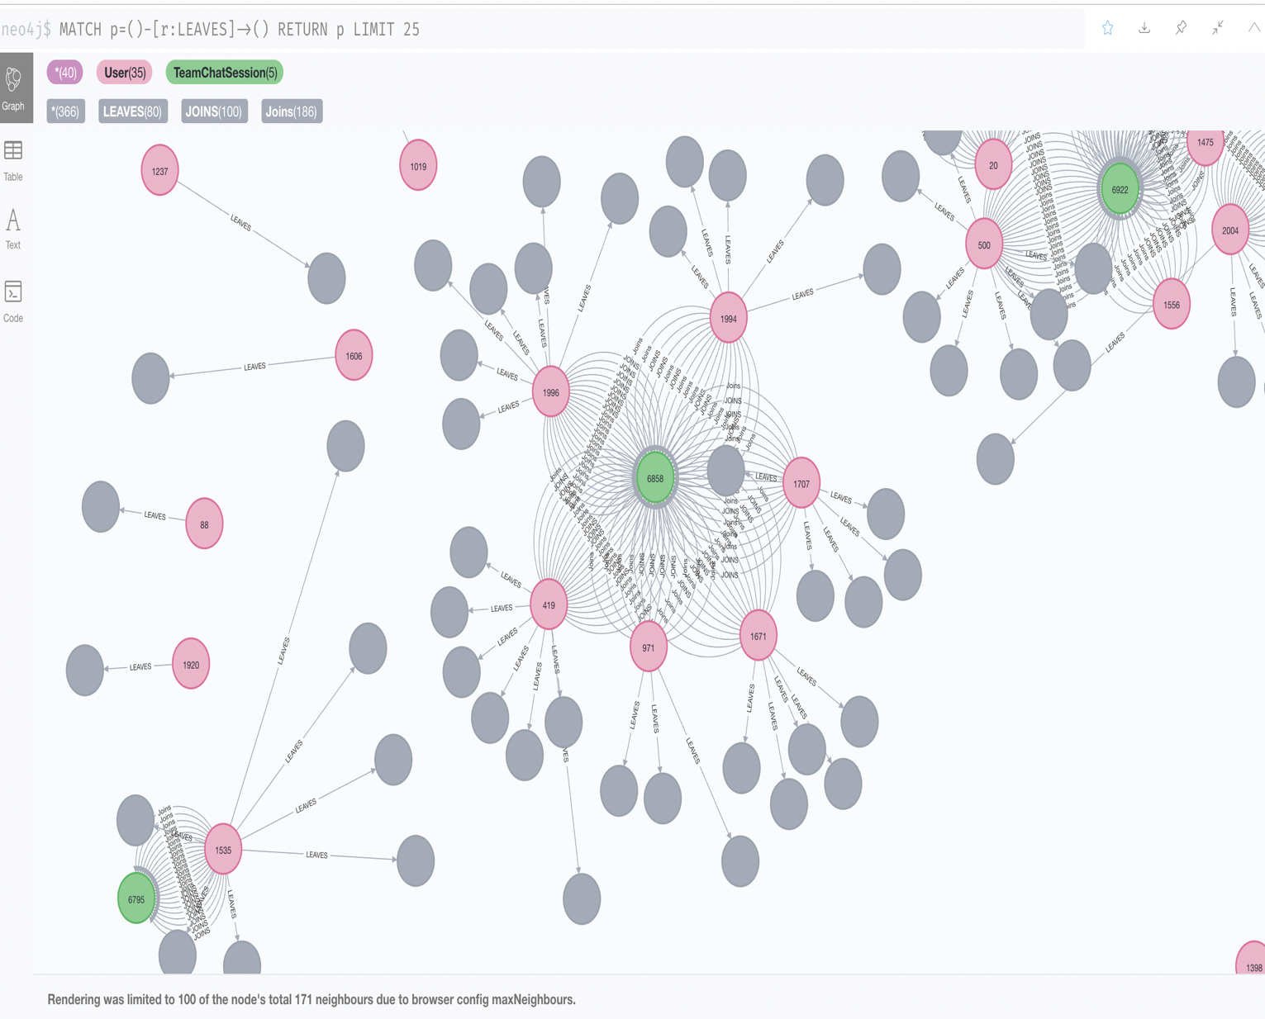

***Figure 22:* Analysing File chat_leave_team_chat.csv**

In the figure below, you can see the graphical representation of the **chat_join_team_chat** dataset. It represents the users joining sessions and relationships between user and user joining TeamChat sessions. For example 368,1792,1095,1125,735 joins chat with 6792.

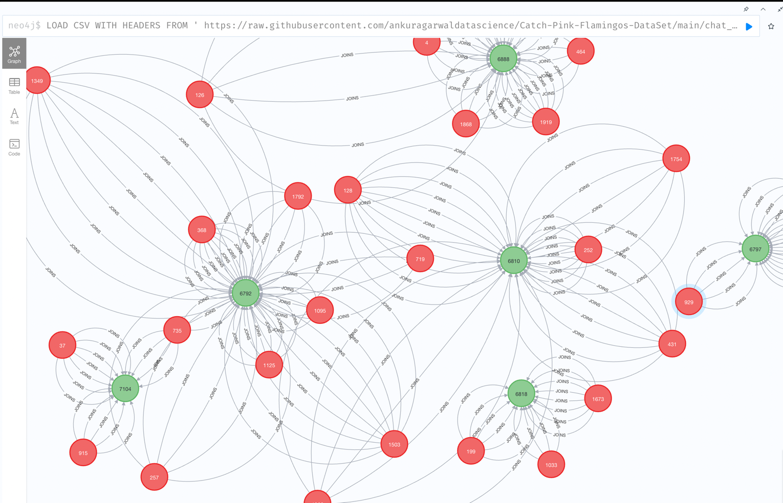

***Figure 23:* Analysing File chat_join_team_chat**

Analysing File chat_mention_team_chat we can see different users mentioned other users in that chat text.

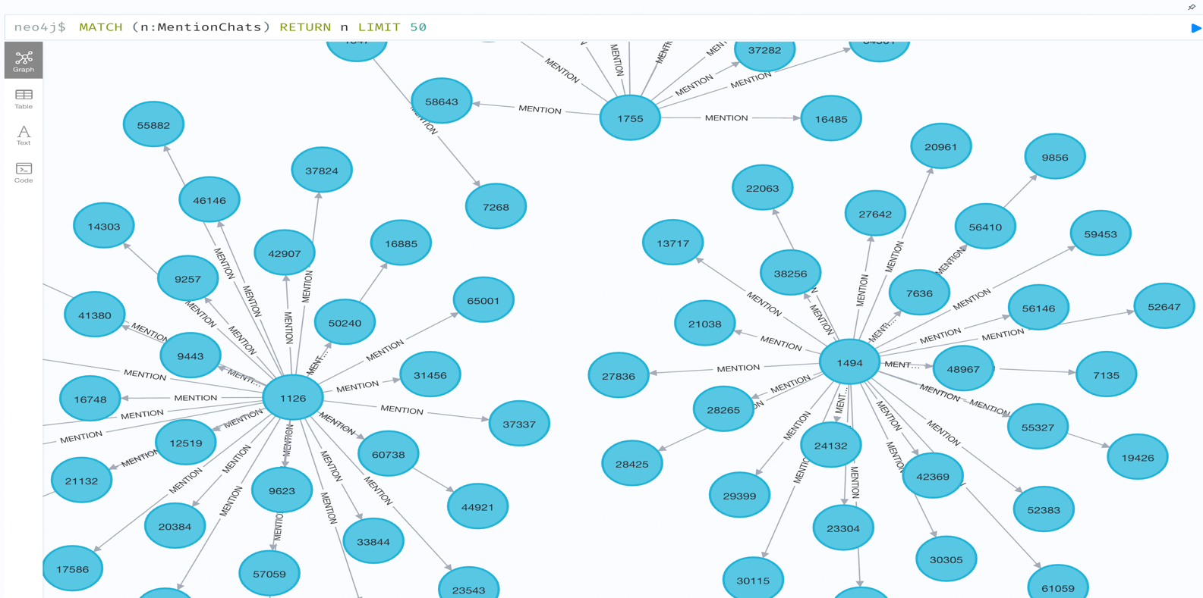

***Figure 24:* Analysing File chat_mention_team_chat**

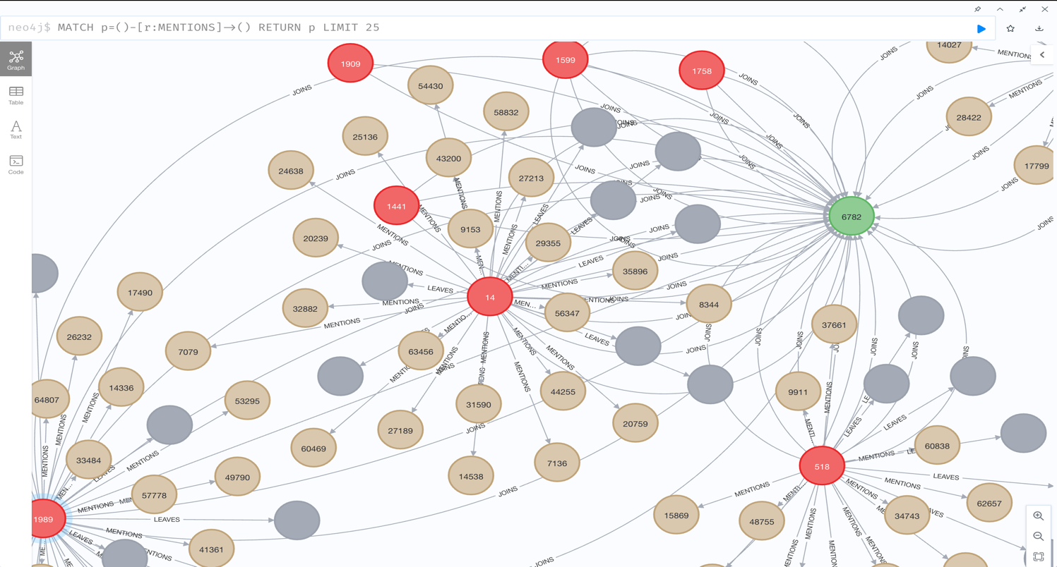

***Figure 25:* Analysing File chat_mention_team_chat**

**Analysing File chat_respond_team_chat**

In the figure below, you can see the graphical representation of the **chat_respond_team_chat** dataset . It is the representation of chat responded.

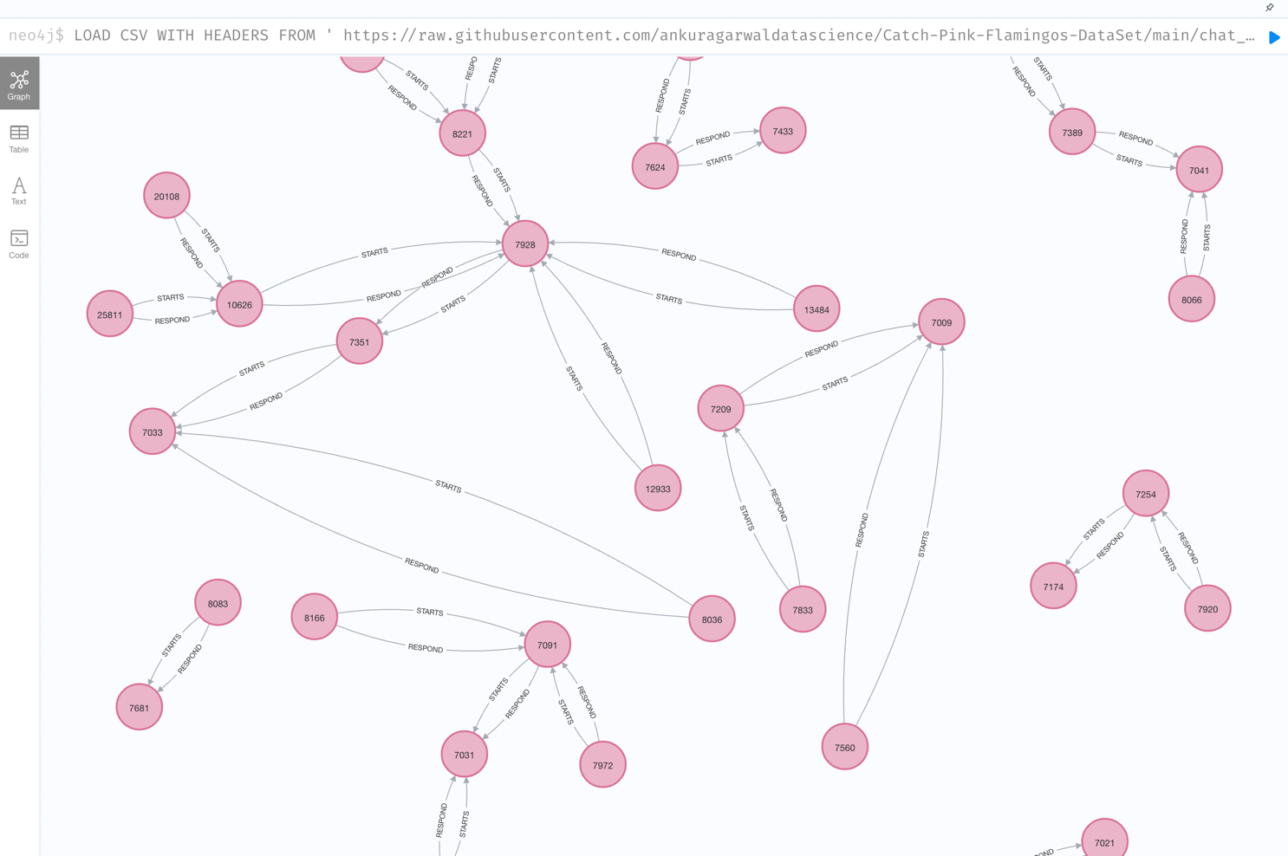

***Figure 26:* Analysing File chat_respond_team_chat**

**Recommendation based on Graph Analytics**

Users who are chattier, initiate longer discussions, and belong to chattier groups and teams are likely to be more valuable when it comes to spreading information to wider audiences. This is what we discussed in the Data Exploration section. Therefore, Eglence, Inc. can increase its revenue by selecting the right marketing strategy to target such customers, such as showing them the more expensive items. Users can influence others in their networks to make such purchases even if they do not intend to purchase them themselves.

It can be calculated how valuable chattier users and users who initiate longer conversations are by comparing, for example, the revenue per user generated by the members of these users' networks and all other users. To perform this analysis, more research is required.

The advantages of more chatty teams and groups include a higher likelihood of their members sharing information. This is in addition to the possibility that such members are similar to each other in some way and, as a result, are likely to purchase similar items.

By comparing items purchased by such teams/groups to items purchased by less chatty teams / less dense groups, an analysis can be made of how similar members of such teams/groups are to each other. Further research needs to be conducted to perform this analysis.

1. **Big Data Ethics**

Ethics for big data means systematizing, defending, and recommending ethical behaviour when working with data, especially personal data. The amount and quality of data have been growing exponentially since the dawn of the Internet. This enormous amount of data is so complex and voluminous that traditional data processing applications are unable to handle it.

To assist with their work in ethics and computer ethics, several institutes and organizations have developed codes of ethics and codes of conduct. According to Thomas Worruba and colleagues, ethics codes should serve at least three purposes.

Individual responsibility was taken for granted in the late 18th century in the modern ethics of Hume, Kant, Betham, and Mills. Big Data today presents ethical implications that require a rethinking of assumptions, particularly about moral agency. Social media was a great platform for discussing, understanding, and debating ethical issues.

Big data ethics has always been a challenge to reconcile with current issues (genomics, drones, etc.). Putting ordinary moral principles in unfamiliar contexts, Johnson (1985) argues that computing ethics "presents new questions that have moral implications." Power, which has played a central role in morality and ethics in the twentieth century, is now widely networked.

**The following are four ethical issues with Big Data that highlight its ethical problems:**

1. The first and most important aspect of "privacy" is that it should be defined as a set of norms. As the era of Big Data progresses, privacy should be considered one of the most important guidelines governing personal data handling. It is not true that "Privacy is dead.". Privacy is still very active; as the amount of data being collected increases, so regulations are needed to control this situation. Our ability to respond to the digital revolution is restricted by privacy regulations as the freedom to keep information (Zwitter, 2014).
2. Secondly, we must understand the supplied information may be "confidential". Over the last few decades, privacy law has been a little bit problematic. Upon the exchange of information and the provision of consent, it is no longer private. In the age of Big Data and Meta Data, it is necessary to exchange (share) private information to design better systems.

State laws have always protected private information. By

recognizing our privacy expectations with Big Data and Meta

Data, we can better recognize how to keep the shared

information private (Zwitter, 2014).

1. It is essential to recognize the need for "transparency" when handling large amounts of data. The use of big data analytics and the consequent sharing of data is making transparency more important than ever in the Big Data era.
2. It is important to realize that large data is capable of sharing an individual's "identity". Identity must also be defined in the same way as privacy. An individual's identity is their ability to describe who they are. Therefore, we must begin to think about it.
3. **Improvement of the Game**

Considering all the above results, we can conclude that Eglance Inc. must invest in game development, and they must be able to attract more iPhone and Android users to generate more revenue. The company should add more ads related to user interests (Computer and Games) to increase revenue. Increasing the number of app clicks results in a greater increase in revenue

1. **GitHub profile link for dataset reference**

https://github.com/ankuragarwaldatascience/Big-Data-Management-Catch-Pink-Flamingos-Project

1. **References**

<https://matplotlib.org/3.5.0/tutorials/colors/colormaps.html>

<https://libraries.io/pypi/pywaffle>

<https://matplotlib.org/3.5.0/tutorials/intermediate/legend_guide.html>

<https://rsandstroem.github.io/sparkkmeans.html>

<https://stackoverflow.com/questions/69887186/legends-not-appearing-in-3d-plot>

<https://matplotlib.org/3.5.0/tutorials/toolkits/mplot3d.html>

<https://hub.knime.com/knime/spaces/Examples/latest/03_Visualization/02_JavaScript/04_Example_for_JS_Bar_Chart~6OgSVMxibsZQNMKT>

<https://www.python-graph-gallery.com/lollipop-plot/>

<https://realpython.com/numpy-scipy-pandas-correlation-python/>

<https://www.scikit-yb.org/en/latest/api/cluster/elbow.html#:~:text=The%20elbow%20method%20runs%20k,point%20to%20its%20assigned%20center>

<https://matplotlib.org/3.5.0/tutorials/toolkits/mplot3d.html>

<https://neo4j.com/developer-blog/15-tools-for-visualizing-your-neo4j-graph-database/>

